Algebra I Name_____________________________________

Unit 6 Polynomial Test Review Date____________________Hour______________

1) Classify 8x3 + 2x2 +5x – 1 by degree and number of terms.

1. Degree: Quartic Terms: Trinomial
2. Degree: Cubic Terms: 4 Term polynomial
3. Degree: Quintic Terms: 4 term polynomial

2) Classify x2(x + 2)(x – 6) by degree and number of terms.

1. Degree: Trinomial Terms: Quartic
2. Degree: Cubic Terms: 5 term polynomial
3. Degree: Quartic Terms: Trinomial
4. Degree: Quartic Terms: 4 term polyomial

3) Find the standard form of y = (x – 2)(x + 1)(x + 4)

4) Given the polynomial y = x4 – 5x – 4 Which is true? Explain why the others are not true:

a) Degree is 6. T or F _________________________________________

b) The x-intercepts are 5, -4, and 1. (Hint: Graph on calc) T or F_______________________

c) The zeros are -5, -4, and 1. T or F___________________________________________

d) The y-intercept is -4. (Show work to prove T or F) __________________

**WORK:**

5) Which graph represents y = -2x3? Please give a reason the other graphs are not correct.

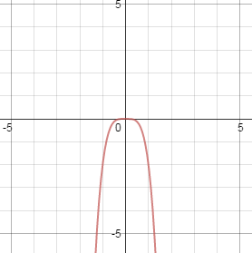

B

A

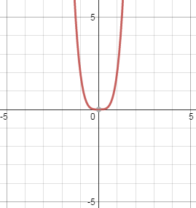

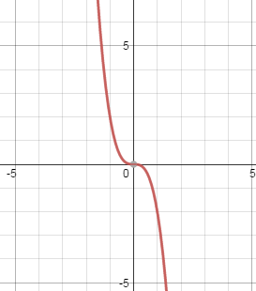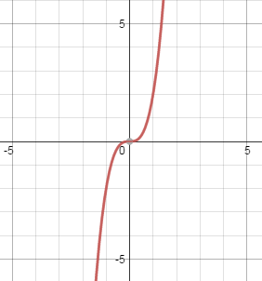

C

D

6) Which of the following is the symbolic form of the polynomial equation the crosses the

x-axis at (-2,0) and (5,0) and touches the x-axis at (3,0). Explain why you choose your answer.

1. y = (x – 2)(x + 5)(x + 3)2

Explain: _______________________

_____________________________

_____________________________

1. y =(x+2)(x + 5)2(x + 3)2
2. y = (x + 2)(x – 5)(x – 3)2
3. y = (x+ 2)(x – 5)2(x – 3)

7) Which of the following polynomial equations is represented by the graph. Explain why you choose your answer:

(HINT: REMEMBER TOTAL ZEROS = # Crossing Zeros + # Touching Zeros)

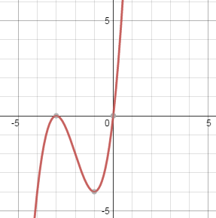

a) y = x(x + 3)

Explain: _______________________

_____________________________

_____________________________

b) y = x2(x +3)

c) y = x(x + 3)2

d) y = x2(x+3)2

8) Which of the following represents the graph of the equation y = x2(3x -5)?

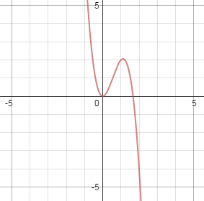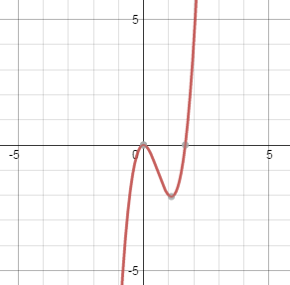

A

B

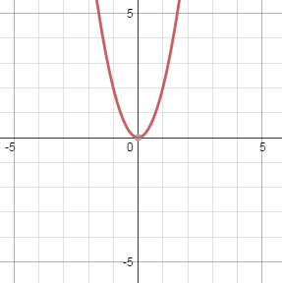

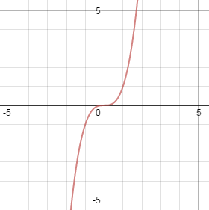

C

D

9) Which of the following represents the equation of an odd power function that has   
*x*-intercepts at (-2, 0) and (0, 0) and whose graph increases as it goes to the right?

1. *y* = -3*x*(*x* + 2)

What Choice can you rule out based on power? ___

What Choices can you rule out based on end behavior?______

1. *y* = *x*2(*x* + 2)
2. *y* = 3*x*(*x* + 2)
3. *y* = -3*x*2(*x* + 2)

10) Which of the following is true about the graph of the function

*f*(*x*) = 5*x*4 - 2*x*2 + 3*x* - 2?

What two things do you look at to determine end behavior?

____________________________________

1. (,)
2. (,)
3. (,)
4. (,)

11) A graph has a leading coefficient that is positive and two real zeros, none of which are repeating. What does this indicate about the graph of the function?

A The graph increases to the right and left.

Besides leading coefficient, what else do you need to consider to answer this question?

____________________________________

B The graph increases to the left

C The graph increases to the right

D The end behavior cannot be determined.

12) The graph of a fourth degree polynomial function has zeros at -5, -6, 1, and 4. Which of the following could represent this function?

A f(x) = (x-5)(x-6)(x+1)(x+4)

B f(x) = (x-5)(x+6)(x-1)(x-4)

C f(x) = (x+5)(x+6)(x-1)(x-4)

D f(x ) = (x+5)(x-6)(x+1)(x+4)

13) Find the zeros of the function f(x) = x3 – 1x2 – 12x (Hint: What must you do first??)

A) x = -3, 0, 4

B) x = -12, -1, 0

C) x = -4, 0, 3

D) x = 0, 1, 12

14) Which of the following polynomial equations is represented by the graph below?



1. 

1. 

1. 

d. 

What Choice can you rule out based on leading coefficient? ______

What zeros are crossing on your graph? ____________

What zeros are bouncing/touching? _____________

15) Find the zeros of the function f(x) =3x(x+1)3(2x + 7)

1. x = 0 with multiplicity of 2, x = -1 with a multiplicity of 3, x = -7/2
2. x = 0, x = -1 with multiplicity of 3, x = -7/2
3. x = 0, x = -1, x = -7/2

16) Which of the following could be the factored form of the equation that is graphed?

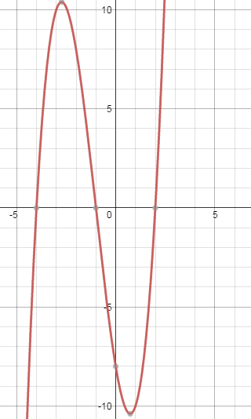

1. y = (x+4)(x+1)(x-2)
2. y = (x+4)(x+1)(x+2)
3. y = (x-4)(x-1)(x+2)
4. y = (x-4)(x-1)(x-2)

What do you need to identify on the on the graph to help you answer this question?

____________________________________