Algebra II Name____________________________
Unit 2B Quadratics Test Review Date___________________Hour______

Standard Form: y = ax² + bx + c
Quadratic equation: x = $\frac{-(b)±\sqrt{{(b)}^{2}-4\left(a\right)(c)}}{2(a)}$

Equation for line of symmetry: x = $\frac{-(b)}{2(a)}$

Vertex Form: y = a(x – h)² + k where (h,k) is the vertex.

The graph opens up when “a” is __________________.
The graph opens down when “a” is ___________________.

- What is the axis of symmetry in the graphed quadratic function?
A
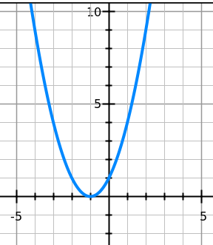
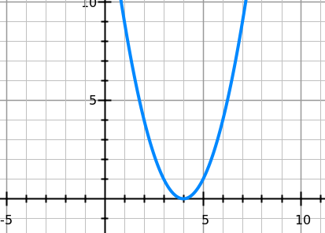
B

Axis of symmetry: _______________
Axis of symmetry: _______________

Page in notebook: _____________
What formula or concept do you need to know for this question?

- The vertex of the graph y = x² is (0,0).
Vertex: _______________
- What is the vertex of the graph y = (x + 6)² – 3?

- What is the vertex of the graph y = -2(x – 9)² – 5?
Vertex: _______________

Page in notebook: _______
Things to remember for this type of question:____________

- Jessica, who has a bionic arm, is crossing a bridge over a small gorge and
decides to toss a coin into the stream below for luck. The distance of the
coin above the water can be modeled by the function h(t) = -16t² + 96t + 112, where h(t) is the height of the coin in feet, above the water, and t is the time in seconds, the coin is in the air. What is the highest height the coin reaches before it drops into the water?

Page in your notebook:______________

What strategy did you use to help you answer this question?

- A manufacturer determines that the number of drills it can sell is given by the
formula D = -3p² + 180p – 285, where p is the price of the drills in dollars.

What is the maximum number of drills they will sell?

Page in your notebook:______________

- The equation of the first graph is y = x². What is the equation of the 2nd graph?
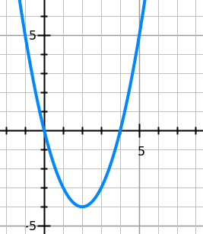
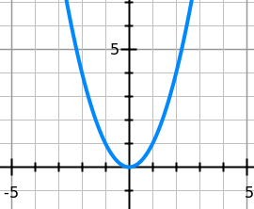

Equation:_____________________________

Strategy: What form should you write the equation in, standard or vertex? (circle one)

How do you find the “a” value? ______________________________________

_____________________________________________________________

What page in your notebook helped you with these problems? ____________________

- The equation of the first graph is y = x². What is the equation of the 2nd graph?
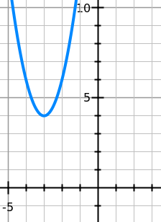

Equation:_____________________________

- The graph below shows the equation y = x². How would the graph of y = 10x² differ from the given graph.
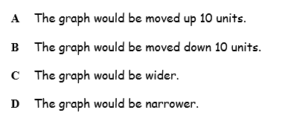

What strategy did you use to help you answer this question?

- Which of the following is true about the graph of the quadratic function
y = 4(x - 6) + 3? Circle the true statement, and write and explanation by the others to Explain why the false statements are false.

- The graph opens down

- The vertex is located at (6, -3).

- The vertex of the graph is a minimum

- The graph has an axis of symmetry at y = -3.

- Solve the following equation by square root method: 2x² – 72 = 0.

Page in notebook__________

- Solve the following equation by Factoring: x² – 5x – 14 = 0
Page in notebook___________

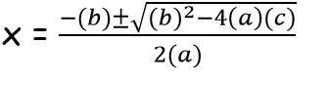
11) Solve the following equation using the quadratic formula.
x² – 5x + 2 = 0 (leave answer in exact form)

Page in notebook______

- Solve the equation by factoring: 3x² + 16x + 5 = 0.

Page in notebook______

- Solve the following by the square root method: x² + 100 = 0

Page in notebook______

- Solve the following by the square root method: 2x² – 144 = 0.

Page in notebook______

- Find the discriminant and number of real solutions of the following equation:
- y = 2x² – 9x – 5 b) y = 5x² – 2x + 10
Page in notebook______

Page in notebook______
- Simplify the following:

- $\sqrt{-175}$ b) $\sqrt{-80}$ c) $\sqrt{-48}$

- Which of the following represents the graph of the quadratic equation whose zeros are -3 and 2 and whose y-intercept is found at (0, -4)?

A B
1
2
3
4
9
8
7
6
5
1
2
3
4
5
6
7
8
9
-1
-2
-3
-4
-5
-6
-7
-8
-9
-1
-2
-3
-4
-5
-6
-7
-8
-9
0
y
x
1
2
3
4
9
8
7
6
5
1
2
3
4
5
6
7
8
9
-1
-2
-3
-4
-5
-6
-7
-8
-9
-1
-2
-3
-4
-5
-6
-7
-8
-9
0
y
x

1
2
3
4
9
8
7
6
5
1
2
3
4
5
6
7
8
9
-1
-2
-3
-4
-5
-6
-7
-8
-9
-1
-2
-3
-4
-5
-6
-7
-8
-9
0
y
x

C D
1
2
3
4
9
8
7
6
5
1
2
3
4
5
6
7
8
9
-1
-2
-3
-4
-5
-6
-7
-8
-9
-1
-2
-3
-4
-5
-6
-7
-8
-9
0
y
x

- Factor 3x² – 7x +2
Page in notebook______

Page in notebook______
- Write the number in the form a + bi.

- $\sqrt{-4}+10$ b) $\sqrt{-25}+7$ c) $\sqrt{-48}+3$

20) Use the quadratic formula to solve.
Page in notebook______
2x² – 5x + 1 = 0

- $\frac{5 ±\sqrt{17}}{2}$ b) $\frac{-5±\sqrt{17}}{4}$ c) $\frac{5 ±\sqrt{17}}{4}$ d) $\frac{5 ±\sqrt{-33}}{4}$

Page in notebook______
- Find the vertex of the following equations:
- y = 2x² + 4x – 5 b) y = 3x – 12x + 2

What did strategy or formula did you use to help you with this problem? ____

- Simplify the following expressions: Write as a + bi
Page in notebook______

- (-1 + 6i) + (-4 + 2i) b) (2 + 8i) + (-3 + -5i)

Page in notebook______
- Simplify the following expressions: Write as a + bi

- (2 – 5i) – (3 + 4i) b) (-3 + 4i) – (6 – 6i)

Page in notebook______
- Find the product of the following. Remember i² = -1

a) (2 + 5i)(-1 + 5i) b) (5 – 4i)(-2 + 5i)

