Family of Functions Name____________________________

Linear, Absolute Value, and Rate of Change Date____________________Hour____

Test Review

Be able to graph an equation in standard form (Ax+ By = C) by rewriting in slope intercept form and by finding the x and y intercepts.

Graph each equation by rewriting in slope intercept form. (SHOW WORK!!) (y = mx + b)

1) 8x + y = -4 2) 3x + 2y = -10

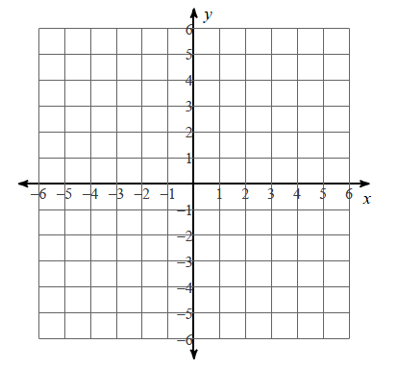

Graph each equation by **finding the x and y intercepts**

3) 2x + 3y = 12 4) 5y – 10x = 30

5) Find the slope between (5,2) and (2, -3) 6) Find the slope between(12,-2) and (-2, -4)

Write the domain and range using interval notation. Determine if it is a function.

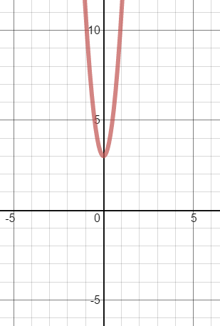7)

Domain:___________

Range:____________

Function:__________

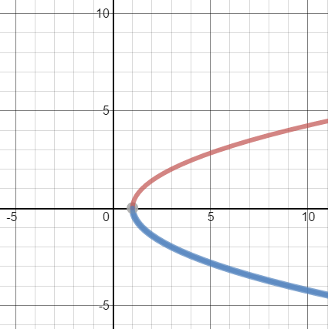8)

Domain:___________

Range:____________

Function:__________

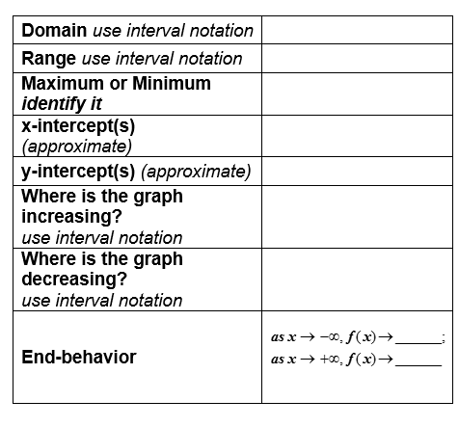9) y = $\left|x-2 \right|$- 1

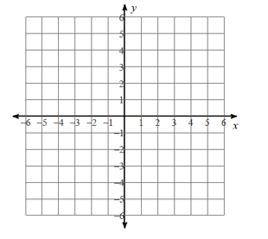

Describe the translations that occurred:



10) y = + 3



Describe the translations that occurred:

11) Write the equation for the translation of y = .

Equation=___________________

12) Write the equation for the translation of y = .

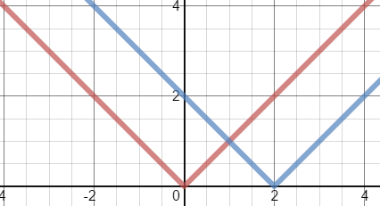

Equation=___________________

13) Write the equation that is the translation of y = $\left|x\right|$ left 1 unit and up 2 units.

Equation=___________________

14) Look at the graph of f(x) = x2 + 1. What is the average rate of change

between?

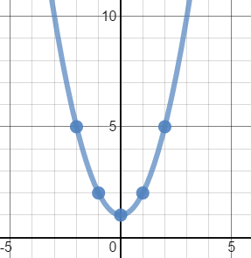

Average rate of change=___________

15) Look at the graph of f(x) = x2 +6x + 10. What is the average rate of change

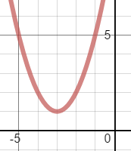 between ?

Average rate of change=___________

16) Look at the table below. What is the average rate of change between $\left[-1,2\right]$?

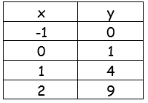

Average rate

of change=___________

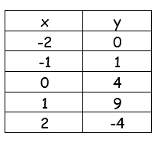 17) Look at the table below. What is the average rate of change between $\left[-2,2\right]$?

Average rate

of change=___________

18) Consider the function y = x2+3. What is the average rate of change between?

Average rate

of change=___________

19) Consider the function y = -x2+3. What is the average rate of change between?

Average rate

of change=___________

20) Find the slope of the line 2x + 5y = 10 slope =__________

21) Find the slope of the line x + 2y = 12 slope = __________