UCS Algebra II Semester 1 REVIEW GUIDE 2 Name ______________

STATS
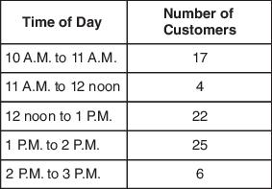
- Mark keeps track of the number of customers he serves each hour at the coffee shop. His results are shown in the table below. Make a histogram that models this data.

- Karisa counted the number of raisins in twenty snack size boxes and found that the number of raisins in each box was normally distributed with a mean of 112 raisins and standard deviation of 8 raisins. What is the probability that a box contains between 104 and 112 raisins?

- Tucker needs to find out the number of defective light bulbs on a truck. He noted that 4 out of 46 light bulbs were defective from a randomly selected box. Based on these results, about how many light bulbs can he expect to be defective in a truckload of 12,500 light bulbs?

- A music teacher wants to conduct a survey to determine how many students plan to attend a school concert. How should she collect a good random sample to give the MOST accurate survey results? Explain your answer.

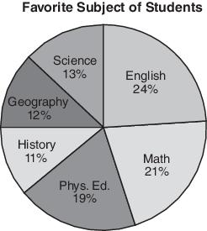
- A sample survey of 2,450 voters revealed that 53% planned to vote for candidate A in an upcoming election. The poll had a $±$3% margin of error. If there are 205,000 total voters, what is the likely range of voters intending to vote for candidate A?

- A survey was conducted at Keller Middle School to determine the favorite subject of students. The results of the survey are shown in the graph to the right.
The total number of students surveyed was 300. How many more students picked English over Math?
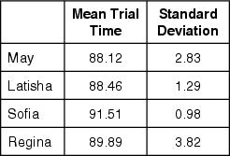
Four downhill skiers recently performed multiple trials on the same run. The table to the right shows the mean times and standard deviations of each skier.
Mean Times for Skiers
A ski coach has to choose one of the skiers to compete in a tournament. The coach wants to choose the skier who most consistently gets a time below 90 seconds. Based on the information in the table, which skier is the BEST choice?

- The following test scores were recorded for two Algebra II classes. Compare the means, medians, and modes. 1st hour: 43, 56, 77, 43, 49, 51
4th hour: 34, 88, 78, 76, 54, 89

- 2000 students were surveyed and showed that 72% of students owned a car with a margin of error of ±4%. What is the percent interval of students who own a car?

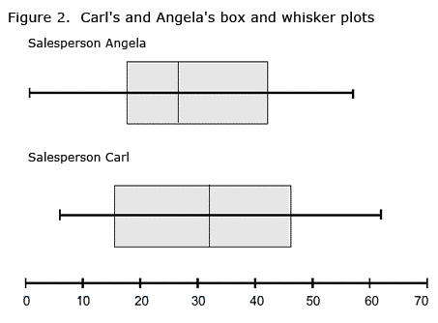
- The Box and Whisker plots show Carl’s and Angela’s sales for the month.

- Who had higher median sales?
- Who had a smaller Inter Quartile Range?
- Compare the ranges?
- Whose standard deviation will be higher?

- Using the Normal Distribution curve, answer the following:
  - What percentage of the data lies within 2 standard deviations of the mean?
  - If there were 800 people in this data set, how many people are between 2 standard deviations above the mean and 1 standard deviation below the mean?

- A survey of 1548 students was conducted to determine what their favorite ice cream was. What is the sample proportion for those who prefer chocolate?
467 prefer vanilla
393 prefer strawberry
512 prefer chocolate
- prefer other flavors

