Algebra I Name_______________________________
Statistics Quiz Review Date__________________Hour_________

74 | 73 | 72 | 76
73 | 72 | 75 | 73
70 | 74 | 73 | 74
For #1 – #4, use the following data set:

The data to the right represents the height, in inches,
of the pitchers for the 2012 San Francisco Giants.

1) Find the Median. 1)________________

2) Find the Mode. 2)________________

3) Find the Mean. 3)________________

4) Draw a Dot Plot

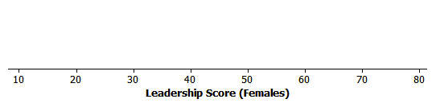
68 69 70 71 72 73 74 75 76 77 78

5) How would you describe the distribution of 5)____________________________
the data in the dot plot you created above?

6) The mean of a data set is 12 and the median is 10. 6)________________________
How would you describe the distribution of the data?

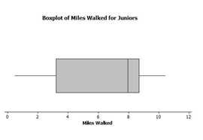
7) Given the following box plot, 7)________________
what is the median of the data?

8) The data to the right shows the number of hours of battery life
12 | 9 | 10 | 14
10 | 18 | 21 | 10
14 | 10 | 11 | 19
for different brands of batteries used in TV remotes.

a) Create a histogram of the battery life using the provided axes.

Hours of Battery Life
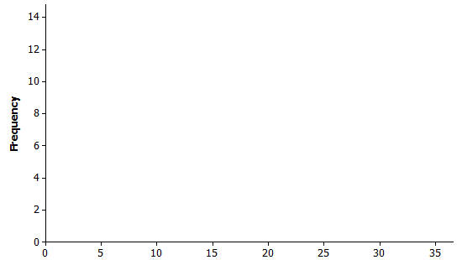
8 10 12 14 16 18 20 22
7
6
5
4
3
2
1
0

b) How would you describe the distribution of b)_______________________
the data in the histogram you created above?

c) Identify the typical amount of hours for battery life. )__________________________

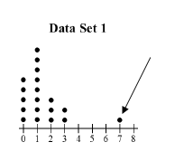
For #9 – #11, use Data Set 1

9) In Data Set 1, what is the term that 9)____________________
could be used to describe the point
in the dot plot indicated by the arrow?

10) What is the median of the data? 10)_______________

11) What is the mean of the data? 11)_______________

