Algebra II Name______________________

Review 13.4 and 13.5 Date________________Hour___

1.  Find the period of the graph shown below.



A) B)

Period: _____________

Period: _____________

1. A particular sound wave can be graphed using the function y = 6sin3 $θ$

Find the amplitude and period of the function.

Amplitude: _________

Period: _____________

3) Find the amplitude, period, and write equation of the sine curves shown below.



Amplitude: _________

Period: _____________

Equation:_____________

Amplitude: _________

Period: _____________

Equation:_____________

1. Write equation of the cosine graphs shown below.
2.  B)

Equation:_____________

Equation:_____________

1. Sketch one cycle of y = -3sin2 $θ$ List your key points. Give the period and amplitude

Amplitude: _________

Period: _____________

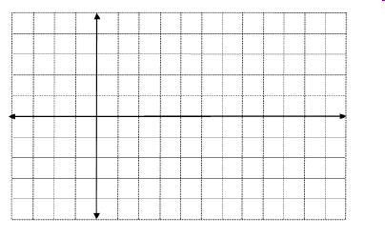

1. Sketch one cycle of y = 4sin $θ$ List your key points. Give the period and amplitude



Amplitude: _________

Period: _____________

1. Sketch one cycle of y = 3cos2 $θ$ List your key points. Give the period and amplitude

Amplitude: _________

Period: _____________

1. Sketch one cycle of y = -2cos $θ$ List your key points. Give the period and amplitude



Amplitude: _________

Period: _____________