Algebra II Name_______________________

Review for Statistics Quiz #1 Date_______________ Hour____

For this quiz you need to be familiar with the following vocab:

Mean Standard Deviation Quartiles

Median Z-Score Inner Quartile Range

Mode Range Box-and-Whiskers Plot

**Find the range, mean, and interquartile range of each set of values.**

1. 10 12 13 10 9 5 6 11 2) 23 56 59 60 123 164 180 212

3) Below are the prices of snowboards at two competing snowboard stores:

**Middletown Snowboards Snowboard Central**

**345, 350, 356, 360, 375, 405 343, 370, 386, 392, 395, 402**

Identify the 5 main statistics of each set of data.

Middletown Snowboards Snowboard Central

(graph above # line) (graph below # line)

Draw a double box-and-whisker plot of the above data on the scale below:



What is the median price for a snowboard at Middletown Snowboards?

What is the range of prices for snowboards at Snowboard Central?

Which price represents the 75th percentile for Middletown Snowboards?

4) In a box-and-whisker plot, each quartile contains _________________ of the data points.

5) The box-and-whisker plot shows the test scores of 32 students in

Mrs. Cowells 2nd hour 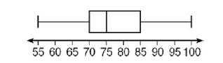Algebra II .

1. What percentage of students scored between 70 and 85? _________
2. How many students scored less than 75? _______________________
3. How many students scored less than 70? ______________________

6) The mean test score on a standardized test is 216; the standard deviation is 52.

Determine the number of standard deviations that includes all data values.

127 98 236 192 267 335 217 365 472 177

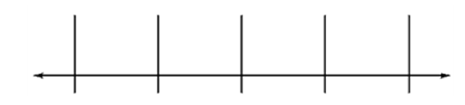

7) The average rainfall for the month of April for several Eastern cities is as follows:

3.0 3.4 4.3 3.6 3.6 2.9 2.8 3.9 2.8 2.9 4.5 3.8 4.2 3.6 4.0 2.9 3.1

**a.** Find the mean of the data. ________

**b.** Find the standard deviation of the data. ____________

**c.** Find the range of the data. ____________

**d.** Within how many standard deviations is a rainfall of 2.8 in.?_____4.0 in.? ___



Identify the outlier of each set of values.

8) 3.4 4.5 2.3 5.9 9.8 3.3 2.1 3.0 2.9 9) 17 21 19 10 15 19 14 0 11 16

10)A set of values has a mean of 67 and a standard deviation of 8. Find the *z*-score of the

value 70.

11)A set of values has a mean of 102 and a standard deviation of 12. Find

the *z*-score of the value 135.

12) On an advanced mathematics placement test, the mean score was 120, with a

standard deviation of 15. If Sara’s z-score is 2.3, what was her score (the value) on the test?

13) The table below gives sample scores of Joe’s and John’s points scored in a b-ball game.

|  |  |  |  |  |  |
| --- | --- | --- | --- | --- | --- |
| Joe | 8 | 10 | 12 | 24 | 6 |
| John | 10 | 8 | 15 | 18 | 9 |

1. What is the mean and standard deviation for Joe? $\overline{x}= _______$ $σ= _______$
2. What is the mean and standard deviation for John? $\overline{x}= _______$ $σ= _______$
3. Using the standard deviation, please explain who is a more consistent scorer ?

_______________________________________________________________________

________________________________________________________________