Algebra II Name__________________________
Review of 8.4 & 8.5 Date__________________Hour_____

Use lesson 8.4 notes to help you with the following problems.

Write the expression as a single logarithm.
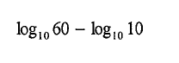
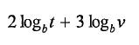
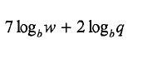
- 2) 3)

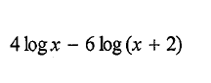
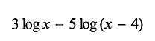
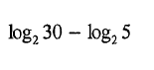
4) 5) 6)

Expand the logarithmic expression.
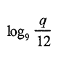
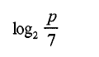
7) 8)

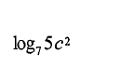

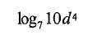
9) 10)

Use lesson 8.5 notes to help you with the following problems.

Round answer to the nearest thousandth if necessary.
11) Solve 15^{3x} = 64 12) 3^{3x} = 19

13) 125^{9x – 2} = 150 14) 110^{8x – 3} = 120

15) log(3x + 11) = 2 16) log(6x + 9) = 3

17) 2logx = -1 18) 3log x = 1.5

19) log4x + log10 = 2 20) log2x + log 7 = 3

