Algebra I Name___________________________
Arithmetic and Geometric Sequences Date_________________Hour_______
Quiz Review
SHOW YOUR WORK!

- Find the common difference and the next two terms of the sequence.

- -4, 3, 10, 17, ... d = ______ Next two terms _______ and _____

- b) 10, 1, -8, -17, … d = ______ Next two terms _______ and _____

- Find the common ratio and the 7th term of the sequence.

a) $\frac{1}{49}$, $\frac{1}{7}$, 1, 7, 49 … r = ___________

7th term= ________

- 16, 4, 1, $\frac{1}{4}$, $\frac{1}{16}$ … r = __________

7th term = _______

- Find the common ratio of the sequence and the next two terms.

- 3, -15, 75, -375… r = ______________________

Next two terms _______ and ______

- 4, 40, 400, …
r = ______________________

Next two terms _______ and ______

Determine if the following sequences are arithmetic, geometric, or neither.
If it is arithmetic or geometric give the common ratio or common difference.
Show your work and circle your answer.
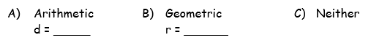
- 13, 26, 39, 52...

- 36, 4, $\frac{4}{9}$, $\frac{4}{81}$, $\frac{4}{729}$ …

- 3, -1, 2, 1, 3…

Write the recursive and explicit formula for the following sequences.
***(YOU NEED TO MEMORIZE THESE FOR YOUR QUIZ! STUDY YOUR NOTES)***

- 18, 15, 12, 9, 6 8) 80, 20, 5, 1.25
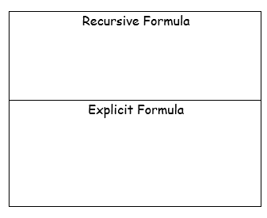

- 97, 104, 111, 118 10) $\frac{1}{36}$, $-\frac{1}{6}$ , 1, -6, 36

