**QUADRATICS**

1. Jamie is building a rectangular dog pen in her backyard with 80 feet of fencing. The pen’s area is given by $A\left(x\right)=x(40-x)$, where $x$ is the length of fencing measured in feet along one side of the pen. Which inequality represents the domain of this function given the context it represents?
2. Determine the quadratic equation that has zeros that $x=-2 and x=5.$
3. 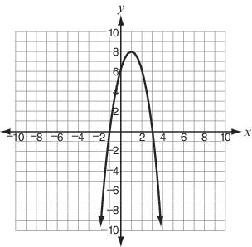Expand ${(u+v)}^{2}$.
4. What is the domain of the function graphed to the right?
5. Factor the following expression.
$12x^{2}-60x+75$

$16x^{2}-24xy+9y^{2}$

$3x^{3}+12x^{2}-15x$

6. Write the expression $5(x-1)(x-3)$ in standard form. What is the coefficient of $x$?
7. What is the sum of and ?
8. Which solutions satisfy the equation ?
9. Write $\sqrt{-25}+2$ as a complex number in the form $a+bi$
10. Which polynomial can be factored over the complex numbers as $4(2x+i)(2x-i)$
11. Find the zeros of the function $f\left(x\right)=2x^{2}+x-3$
    1. Write $f\left(x\right)$ in factored form.
    2. Find the roots.
    3. Find the maximum or minimum value.
    4. State the axis of symmetry.
12. Graph $f\left(x\right)=x^{2}-4.$
13. Find a function, *g(x),* that opens in the same direction as *f(x)* but that represents a narrower parabola. Explain your work.
14. Graph *g(x).*
15. Find the roots to the equation: $2x^{2}+26x+72=0$
16. Name two other terms we use for roots.
17. Find the difference. $\left(2+7i\right)-\left(-6-10i\right)$
18. Find the sum $\left(2+7i\right)+\left(-6-10i\right)$
19. Find the product $\left(2+7i\right)∙\left(-6-10i\right)$
20. If $y=2x^{2}-5$ and the domain is all negative real numbers, what is the range of the function?