Algebra II Name________________________________
Review Quadratic Functions Worksheet

Find the equation of the axis of symmetry and the coordinates of the vertex of the graph of each function.
AOS:________

Vertex:________
AOS:________

Vertex:________
- y = 2x² + 4 2) f(x) = 2x² + 4x – 5

AOS:________

Vertex:________
AOS:________

Vertex:________

3) y = x² – 8x – 9 4) y = 3x² – 9x + 5

Graph each functionon without a calculator. On the graph, label the axis of symmetry and the vertex.
(FIND THE VERTEX BY HAND, NO GRAPHING CALCULATOR)

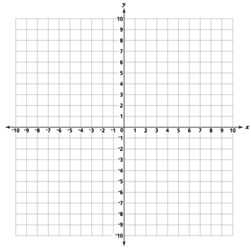
11) f(x) = x² + 4x + 4 12) y = 2x² – 6x

13) y = -x² + 4x – 4 14) f(x) = 2x² + 3x + 1

15) A ball is thrown in the air with an upward velocity of 40ft/s. Its height in feet after t seconds is given by the function h = -16t² + 40t + 6.

- In how may seconds does the ball reach its maximum height?

- What is the ball’s maximum height?

