Algebra I Name___________________
Setting Pavers Worksheet Date______________Hour__
_______

Problem 1 – Setting Pavers
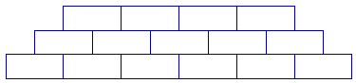
You are setting pavers in a courtyard according to the pattern shown. How many total pavers will there be in all 50 rows?
Row 1
Row 2
Row 3

- Create a table showing the total number of pavers in the courtyard given the number of rows. Give the first six rows.

- What type of a polynomial function will model this situation? How do you know?

- Write the polynomial function that will model this situation.

4) For the given situation, state the domain of the function. Explain.

5) Based on your model give the total number of pavers in the courtyard if there are 10 rows of pavers?

6) Based on your model give the total number of pavers in the courtyard if there are 50 rows of pavers?

