LINEARS/ALGEBRA 1

- The last math test had 28 questions consisting of TRUE and FALSE questions (2 points each) and SHORT ANSWER questions (3 points each). If the test was worth 64 points, how many of each type of question is there?
- Write a set of equations that models this situation.
- Solve the system of equations using elimination or substitution.
- Kristen is 2 times as old as her younger brother, Luke. Which equation represents their ages, in years, if Kristen’s age is k and Luke’s age is l?
- A club is selling hats and jackets as a fundraiser. Their budget is $1500 and they want to order at least 250 items. They must buy at least as many hats as they buy jackets. Each hat costs $5 and each jacket costs $8. Let h = number of hats and j = number of jackets.
- Write a system of inequalities to represent the situation.
- Graph the inequalities.
- If the club buys 150 hats and 100 jackets, will the conditions be satisfied?
- Heather graphed the following equations.
Equation 1: $y=\frac{4}{3}x-2$
Equation 2: $12x-9y=27$
Equation 3: $2x+4y=-8$
- How do the graphs of equations 1 and 2 compare? What is their point of intersection?
- How do the graphs of equations 1 and 3 compare? What is their point of intersection?
- Use words, numbers, and/or pictures to show your work.

- John’s grade is twice as high as Stacy’s. If j is John’s grade and s is Stacy’s write two equations to model this situation.
- On a boating trip in Minnesota the temperature was 76º at 8:00 am. By 2:00 pm the temperature had risen to 88º. What was the average rate of change in degrees per hour?
- This graph shows the Revenue and Expenses for a company from 1994 to 2003.
- The expenses in 1996 are twice as much as the revenue. TRUE or FALSE. Explain.

- The difference in revenues between 1999 and 2000 is about 10 billion. TRUE or FALSE. Explain.

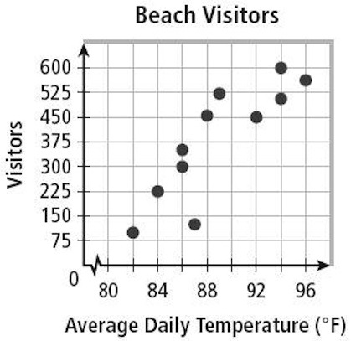
- The following scatterplot shows the number of beach visitors compared to the average daily temperature.

- The data shows a positive trend.
TRUE or FALSE. Explain.

- The data shows that as temperature rises there are ALWAYS more visitors.
TRUE or FALSE. Explain.

