STATS
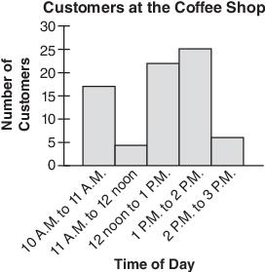

- 34%
- about 1087 bulbs
- Answers may vary
- between 102,500 and 114,800 voters
- 9 students
- LATISHA
- 1ST: Mean: 53.17, Median: 50, Mode: 43
4th: Mean: 69.83, Median: 77, Mode: No mode
- $68\%-76\%$ which is 1360 – 1520 students

- a)Carl b)Angela c) approx. 57, same for both d)Carl

- a) 95% b) 652 people

- $\frac{512}{1548}=.33=33\%$

