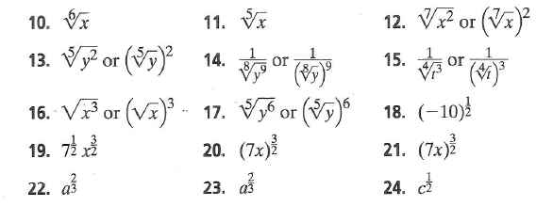
Key for Page 382 Problems 10 – 24

