Key LINEARS
- a)$\left\{\begin{aligned}x+y=28 \\ 2x+3y=64\end{aligned}\right.$ b) 20 T/F and 8 Short Answer

- l = $\frac{k}{2}$ or k = 2l

- a) $\left\{\begin{aligned}h+j≥250 \\ 5h+8j≤1500 \\ h≥j\end{aligned}\right.$
c) No, the cost will be $1550, which is greater than $1500

- The slopes are the same for equations 1 and 2. Since the lines have the same slope and different y-intercepts, they are parallel and do not intersect.
- The slopes are different. Since the slopes of the lines are not the same, the lines are not parallel. Therefore, they intersect.
Intersect at (0,-2)
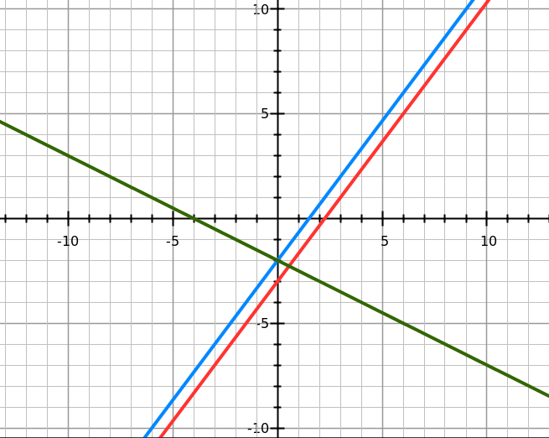

- $j=2s or s=\frac{j}{2}$
- $2°/hour$

- a) False, expenses are $60,000 and Revenue is $50,000. The graph starts at 40,000 not 0.

b) True. 65-55=10 and 10,000 million = 10 billion

- A) True, as the temperature increases the visitors increase.

- False, it does not ALWAYS show more visitors when the temp rises. Most of the time, but NOT ALWAYS.

