Algebra II Name__________________
Lesson 13-1 Periodic Functions WS
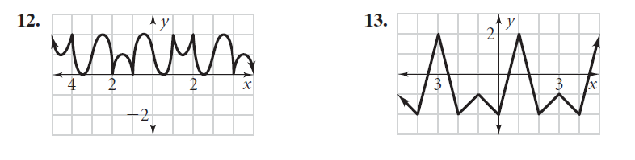
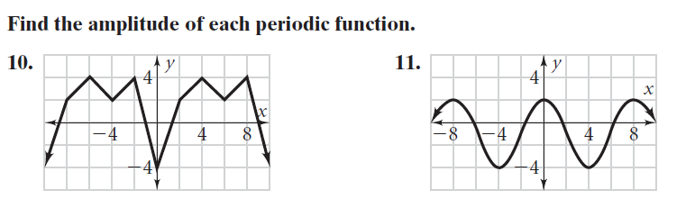
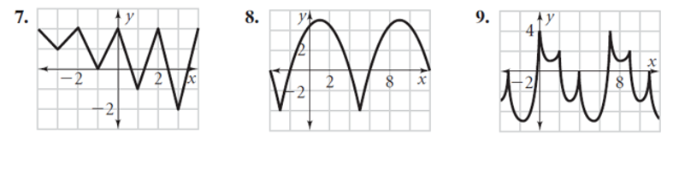
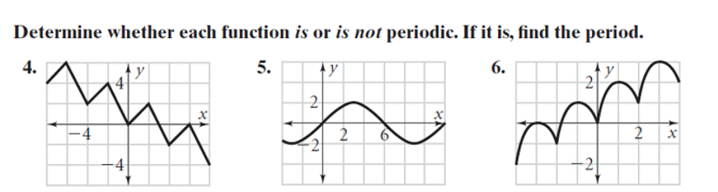
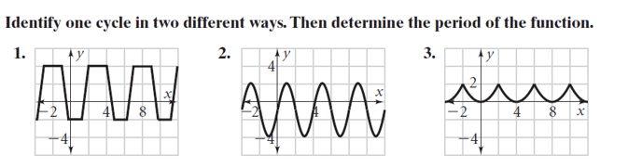
HW #7

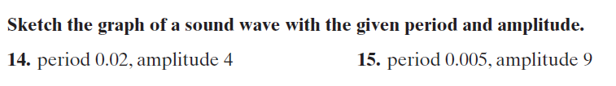

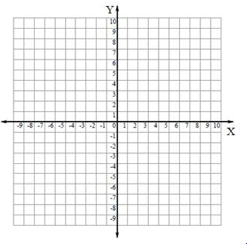
1 unit on the x-axis is 0.01
1 unit on the x-axis is 0.01

Find the maximum, minimum, and period of each periodic function.
