Algebra II Name____________________
Review 13.2 and 13.3 Date_____________Hour____
Homework #6

Use the unit circle in your notebook to help answer these questions. Find the exact coordinates of the point where the terminal side of the given angle intersects the unit circle. Then find the decimal equivalents. Round your answers to the nearest hundredth.

- 45$°$ 2) 225$°$ 3) -45$°$ 4) -150$°$ 5) 630$°$
X = _____ $≈$______
Y =_____ $≈$______
X = _____ $≈$______
Y =_____ $≈$______
X = _____ $≈$______
Y =_____ $≈$______
X = _____ $≈$______
Y =_____ $≈$______
X = _____ $≈$______
Y =_____ $≈$______

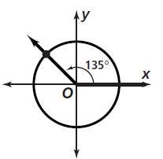
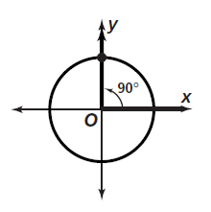
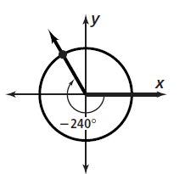
6) 7) 8)
X = _____ $≈$______
Y =_____ $≈$______
X = _____ $≈$______
Y =_____ $≈$______
X = _____ $≈$______
Y =_____ $≈$______

Write each measure in radians. Express your answer in terms of π

9) 45° 10) 90° 11) 30° 12) 150° 13) 240°

14) 40° 15) 80° 16) 110° 17) 160°

Write each measure in degrees. Round your answer to the nearest degree, if necessary.

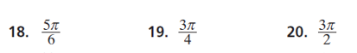

The measure of an angle in standard position is given. Find the exact
values of cos $θ$ and sin $θ$ for each angle measure.

Cos $θ$ = ______

Sin $θ$ = ______

Cos $θ$ = ______

Sin $θ$ = ______

Cos $θ$ = ______

Sin $θ$ = ______

Cos $θ$ = ______

Sin $θ$ = ______

Cos $θ$ = ______

Sin $θ$ = ______

Cos $θ$ = ______

Sin $θ$ = ______

Cos $θ$ = ______

Sin $θ$ = ______

Cos $θ$ = ______

Sin $θ$ = ______

