Algebra II Name_____________________
Piecewise Functions Date____________Hour______
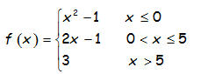
HW #6

- Evaluate the following with the given function.

- f(-5) b) f(0) c) f(4) d) f(5) e) f(10)

- Graph the following function

f(x) = _____________ f(x) = _____________ f(x) = ____________
Domain:____________ Domain:____________ Domain:_________
x | y

x | y
x | y

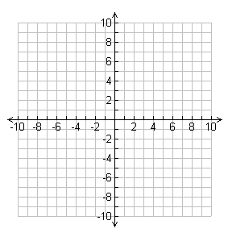
Range: __________ Range: __________ Range:_________

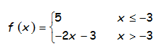
3) Graph the following function:

f(x) = _____________ f(x) = _____________
x | y
Domain:____________ Domain:____________
x | y

Range: __________ Range: __________

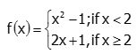

4) Graph the following function:

f(x) = _____________ f(x) = _____________
x | y
Domain:____________ Domain:____________
x | y

