Algebra II Name____________________________________
Lesson 12-7 Normal Distributions Date_________________Hour________________
HW # 6 WS
 | A set of data with a mean of 45 and a standard deviation of 8.3 is normally distributed. Find each value, given its distance from the mean.
 | 1. +1 standard deviation from the mean |  | 2. +3 standard deviations from the mean
 | 3. −1 standard deviation from the mean |  | 4. −2 standard deviations from the mean
 | Sketch a normal curve for each distribution. Label the x-axis as one, two, and three standard deviations.
 | 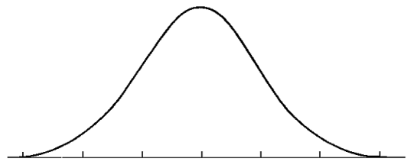  5. mean = 95; standard deviation = 12 |  | 6. mean = 100; standard deviation = 15
 | A set of data has a normal distribution with a mean of 5.1 and a standard deviation of 0.9. Find the percent of data within each interval. Sketch curve in the space below.
 | 7. between 4.2 and 5.1 | 8. between 6.0 and 6.9 |  | 9. greater than 6.9
 | 10. between 4.2 and 6.0 | 11. less than 4.2 |  | 12. less than 5.1
13. Scores on an exam are normally distributed with a mean of 76 and a standard deviation of 10. Sketch curve below
a) In a group of 230 tests, how many students score above 96? |  | b) In a group of 230 tests, how many students score below 66? |  | c) In a group of 230 tests, how many students score within one standard deviation of the mean?
14. The number of nails of given length is normally distributed with a mean length of 5.00 in. and a standard deviation of 0.03 in. Sketch curve below.
a) Find the number of nails in a bag of 120 that are less than 4.94 in. long. |  | b) Find the number of nails in a bag of 120 that between 4.97 and 5.03 in. long. |  | c) Find the number of nails in a bag of 120 that are over 5.03 in. long.

