Algebra II Name______________________________
Average Rate of Change Worksheet Date___________________Hour_______
Homework #5

- Look at the graph of f(x) = x² + 1. What is the average rate of change between$\left[-1,3\right]$?
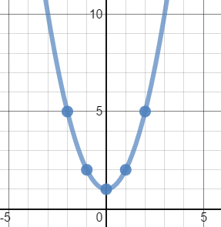

2) Look at the graph of f(x) = x² +6x + 10. What is the average rate of change between$\left[-2,1\right]$?
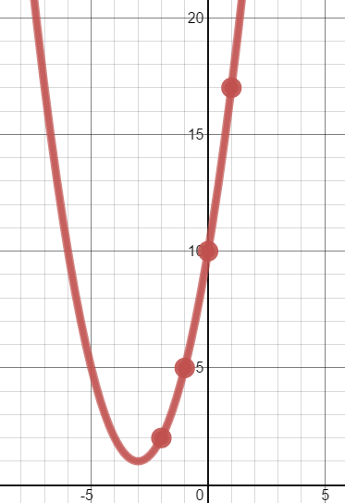
3) Look at the table below. What is the average rate of
change between $\left[-1,3\right]$?

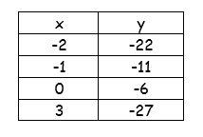

4) Look at the table below. What is the average rate of change between$\left[-4,4\right]$?

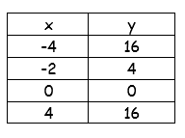

5) Consider the function y = x²+4. What is the average rate of change between$\left[1,5\right]$?

6) Consider the function y = -x²+4. What is the average rate of change between$\left[1,5\right]$?

7) Consider the function y = ½x²+4. What is the average rate of change between$\left[-2,6\right]$?

8) Consider the function y = 3x² – 3. What is the average rate of change between$\left[-3,3\right]?$

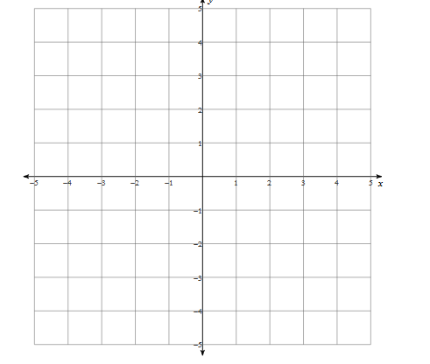
9) Sketch a graph of a function that has a negative average rate of change between $\left[0,3\right].$

