Algebra II Name__________________________________
Lesson 7-5 Solving Radical Equations Date___________________Hour__________
Homework #3

Solve. Check for extraneous solutions.
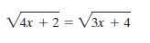
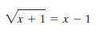
- 2)

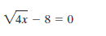
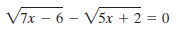
3) 4)

