Algebra II Name___________________________
Lesson 5-2 Standard Form of a Quadratic Date__________________Hour______
HW #2

Rewrite each function in standard form (y = ax² + bx +c). Determine if it is quadratic or linear.

- f(x) = x(x+5) – 2x 1)______________________________

- f(x) = 8x² + 10 – 6x – 8x² 2)______________________________

What are the vertex, the axis of symmetry, the maximum or minimum value, and the range of each parabola? (Hint: Label a, b, and c values)

- y = −x² + 2x − 5 4) y = −2x² − 8x + 3 5) y = 4x² − 2x + 1

Vertex: ____________
Axis of Symmetry: ______
Max or min value:________
range: ________
y –intercept:_______
Vertex: ____________
Axis of Symmetry: ______
Max or min value:________
range: ________
y –intercept:_______
Vertex: ____________
Axis of Symmetry: ______
Max or min value:________
range: ________
y –intercept:_______

- Graph each function by plotting 3 points. (incl. vertex) . Label the vertex and axis of symmetry. (DO WITHOUT CALCULATOR)
Vertex: ______
AOS:_________
Vertex: ______
AOS:_________
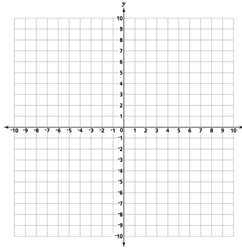
6) y = -x² – 2x + 2 5) y = 5x² + x + 8

Sketch each parabola using the given information

6) Vertex is (-2,1) 7) Vertex is (3,-5)
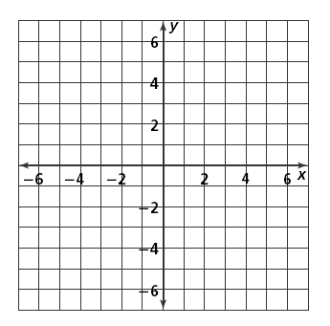
y-intercept is 4 point (4,1)

8) . The height of a batted ball is modeled by the function h = −0.01x² + 1.22x + 3, where x is the horizontal distance in feet from the point of impact with the bat, and h is the height of the ball in feet.

- At what distance from the point of impact (x) will the ball reach the maximum height?

b. What is the maximum height that the ball will reach?

9) A rock club’s profit from booking local bands depends on the ticket price. Using past receipts, the owners find that the profit p can be modeled by the function p = -15t² + 600t + 50, where
t represents the ticket price in dollars.

a. What ticket price yields the maximum profit?

b. What is the maximum profit?

