Algebra II Name___________________________
Lesson 8-1 Date____________________Hour___
Homework #1
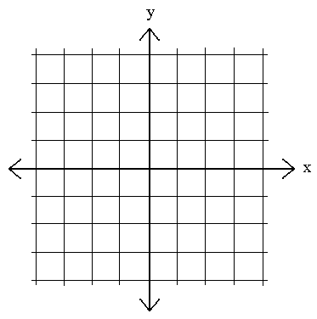
Graph each function.
1. y = 6^{x} 2. y = 3(10)^{x}

4. The world population in 2000 was approximately 6.08 billion.
The annual rate of increase was about 1.26%.

- Find the growth factor for the world population. _________

- Suppose the rate of increase continues to be 1.26%. Write a
function to model world population growth.
_____________________

Write an exponential function y = ab^{x} for a graph that includes the given points.

4. (4, 8), (6, 32) 5. (2, 122.5), (3, 857.5) 6. (2, 18), (5, 60.75)

Without graphing, determine whether each function represents exponential growth
or exponential decay.

7. y = 129(1.63)^{x} 8. f(x) = 2(0.65)^{x} 9. y = 12($\frac{17}{10}$)^{x} 10. y = 0.8^{x}

Graph each function. Identify the horizontal asymptote.

11. y = (0.75)^{x} 12. y = 2(0.5)^{x}

13. A computer valued at $6500 depreciates at the rate of 14.3% per year.

a. Write a function that models the value of the computer.

- Find the value of the computer after three years.

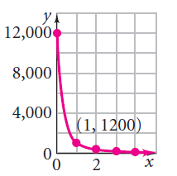
14. Write an exponential function for each graph. Evaluate the function for x = 6.

