Algebra II Name_________________________
Lesson 11-2 Arithmetic Sequences Date_______________Hour______
Homework #1 WS
Show your work!!!

Is the given sequence arithmetic? If so, identify the common difference.
1) 1, 4, 9, 16 … 2) 10, 20, 30, 40, … 3)1, 1, 2, 3, 5, 8,… 4) -21,-18,-15,-12,…

Write a recursive and explicit formula for the arithmetic sequence, then use the formula to find the given term.

5) 34, 37, 40, 43…. 6) 213, 201, 189, 177,… 7) 0.1, 0.5, 0.9, 1.3, …

Recursive Formula:

Explicit Formula:

Find 10th term:
Recursive Formula:

Explicit Formula:

Find 25th term:
Recursive Formula:

Explicit Formula:

Find 40th term:

8) You visit the Grand Canyon and drop a penny off the edge of a cliff. The distance the penny will fall is 16 feet the first second, 48 feet the next second, 80 feet the third second, and so on in an arithmetic sequence. What is the distance the penny will fall the 20th second?

9) You are setting pavers in a court yard according to the pattern shown.
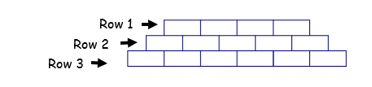

- Write an explicit model for this sequence where n stands for the row number.

- How many pavers will there be in the 50th row?

