Algebra II Name____________________________
Graphing Linear Equations and Writing Equations Date______________Hour__________
Homework #1

Find the slope of the line through each pair of points.
- (-3, 9) and (0,3) 2) (-3,5) and (4,5)

Write an equation for each line.
3) m = 3 and the y-intercept is (0,2) 4) m = 0 and the y-intercept is (0,-2)

Write each equation in slope intercept form. Then find the slope and y-intercept of each line. Then graph the line.

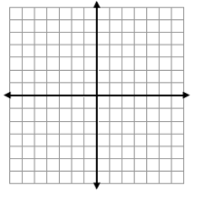
5) 5x + y = 4 6) -4x + 2y = 8

Slope(m):_______
y-int (b):______
Equation:_____________

Slope(m):_______
y-int (b):______
Equation:_____________

7) -12x + 6y = 30

Slope(m):_______
y-int (b):______
Equation:_____________

8) 5x – 2y = -4

Slope(m):_______
y-int (b):______
Equation:_____________

9) -3x – 2y = 10

Slope(m):_______
y-int (b):______
Equation:_____________

