1 | Solve for x: $12+2\sqrt{5x+6 }=24$
 | A | x = 5 | C | x = 6
 | B | x = 36 | D | x = 12

2 | Write an exponential function for the graph pictured.  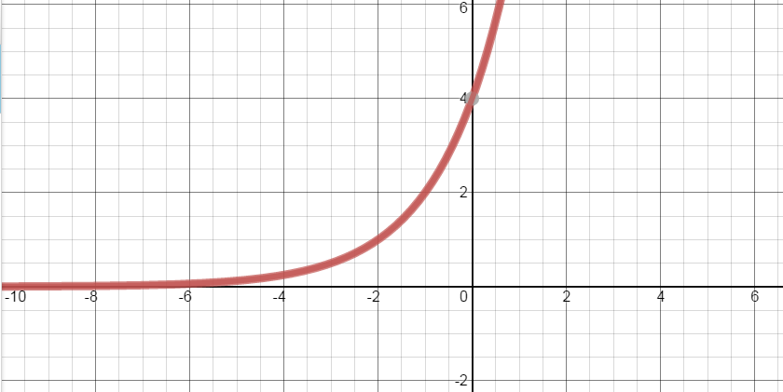
 | A | $$y=2{(4)}^{x}$$ | C | $$y=4{(.5)}^{x}$$
 | B | $$y=4{(2)}^{x}$$ | D | $$y={(4)}^{x}$$

3 | The value of an object decreases by 15% each year. The value of the object can be modeled with the equation A = P (0.85)^{t}, where P is the original value and A is the value after t years. If the original value of the object is $200,000, in how many years will it be worth $122,825.?
 | A | ½ year | C | 1 year
 | B | 2 years | D | 3 years

4 | The half-life of a certain radioactive material is 5 days. An initial amount of the material has a mass of 20kg. Which graph represents how much of the substance is left after x days?
 | A | 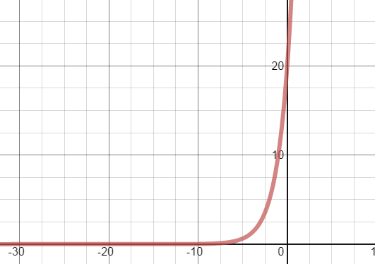 | C | 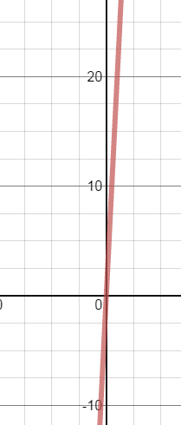
 | B | 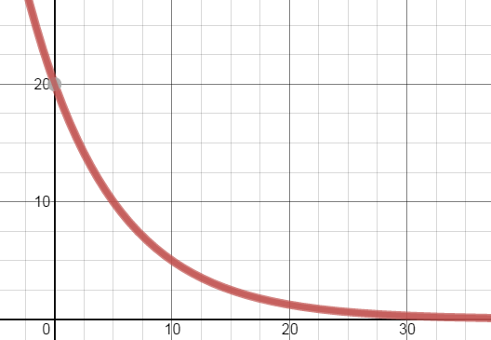 | D | 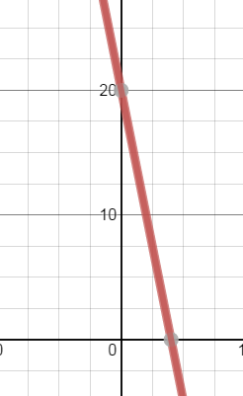

5 | Which equation is the same as 3 = 1000^{b}?
 | A | $$\log_{3}{1000=b}$$ | C | $$\log_{b}{1000=3}$$
 | B | $$\log_{3}{b=1000}$$ | D | $$\log_{1000}{3=b}$$

6 | What is the inverse of $f\left(x\right)=44^{x}$
 | A | $$f^{-1}\left(x\right)=\log_{x}{44}$$ | C | $$f^{-1}\left(x\right)=44logx$$
 | B | $$f^{-1}\left(x\right)=x^{44}$$ | D | $$f^{-1}\left(x\right)=\log_{44}{x}$$

7 | Write the equation 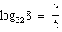 in exponential form
 | A | 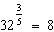 | C | 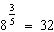
 | B | 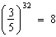 | D | 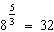

8 | Solve for x: log₃x = 5.
 | A | x = 15 | C | x = 243
 | B | x = 125 | D | x = 8

9 | Which is the approximate answer when solving for x: 5 + 125^{9x-2} = 155
 | A | x = 0.25 | C | x = 0.4125
 | B | x = 0.5 | D | x = 0.3375

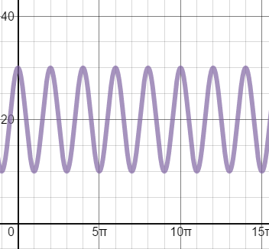
10) Which equation describes the graph?

- Y = 30cos(x) – 10 | - Y = 10cos(x) + 20
- Y = 10cos(x) – 20 | - Y = 30cos(x) + 20

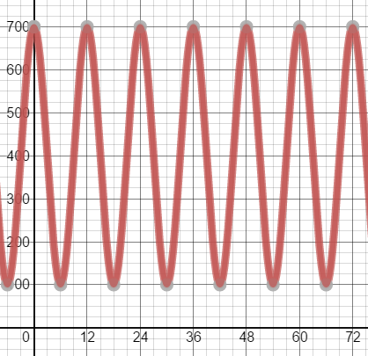
11) Which equation describes the graph?

- Y = 700cos($\frac{π}{6}$x) – 600 | - Y = 100cos($\frac{π}{12}$x) + 600
- Y = 300cos(x) + 400 | - Y = 300cos($\frac{π}{6}$x) + 400

12) Which graph shows the function y = sin(x), transformed so that it has an amplitude of 4 and a period of $π$ and is translated up 5 units?
